9. G TJA UČENJE NA DALJAVO – 4. TEDEN (23.11. - 27.11.2020)

1. MORE ABOUT JOBS
A: Who works there?
OFFICE | RESTAURANT | AIRPORT | SCHOOL | HOTEL | FACTORY

B:Job requirements: Which are the jobs that need / have to….. ?
- have a special training
- get on well with people
- speak foreign languages
- know a lot of facts
- be well dressed
- good at sports
- wear uniforms
- work the nightshift
C: Name some jobs which are:
- creative
- dangerous
- well paid
- exciting
D: A job posting (objave za službo)
- Job ad
- Job advert
- Job advertisement
- Job announcement
- Employment ad
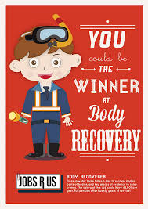
- Hiring ad
- Recruitment ad

E: Answer the questions:
1. Which of the above jobs requires little / a lot of knowledge?
- physical ability?
- college degree?
- a special training?
2. What do the jobs have in common?
How do they differ?
3. Which job is creative / which one dangerous?
4. Which of the jobs have you found interesting? Which one would you apply for?
5. What would you like to do in your life? What job would you like to do? (5-10 sentences)

Lep pozdrav in bodite zdravi, učiteljica Vida Lunka

