5. G TJA UČENJE NA DALJAVO – 5. TEDEN (7.12. - 11.12. 2020)

1. Opišite žival na sliki; uporabite sledeče besede:
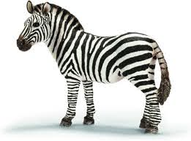
a hoof /hooves – kopita
a mane – griva
stripes - črte

2. LET’S EXPLORE – KONRAD, THE MAGICIAN (čarovnik)
(dvojni levi klik na ikonco)

A: Poslušajte posnetek besedila iz učbenika na str.14-15. Nato ga večkrat preberite na glas. Pazite na izgovorjavo.
B: Iz slovarja prevedite naslednje besede:
a magic show - ____________ a parrot - _____________
a cape - _____________ a magic box - _________________
to blow up - ______________ empty - ____________ full - ______________
a magic wand - _______________ a scarf - ____________

C: Odgovorite na sledeča vprašanja: ANSWER THE QUESTIONS:
- Where are Jessica and Konrad?
- Who is a magician?
- What does he look like?
- What has he got?
- What can he do with the baloons?
- What's in the box?
- What is Konrad wearing?
- Where is his watch?
3. Odgovori pravilno; učb. 12 / 2
PRIMER: IS this a man? – Yes, he is. / No, he isn't.
HAS a girl got a ponytail? - Yes, she has. / No, she hasn't.
Is your dad a postman? - _____________________
Has your mum got a watch? - _______________________
Is your friend tall? - ________________________
Has yor brother / sister got long hair? - ________________________
Is your mum slim? - ________________________
Has a dog got a liong tail? - ____________________
BYE.

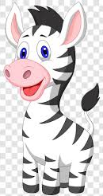
Lep pozdrav, učiteljica, Vida Lunka

