5. G TJA UČENJE NA DALJAVO – 6. TEDEN (14.12. - 18.12. 2020)

1. PONOVIMO: Opišite ptička na sliki:
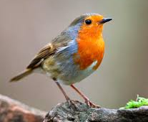
(Vir: https://see.news/)

2. A HOUSE CHIMNEY
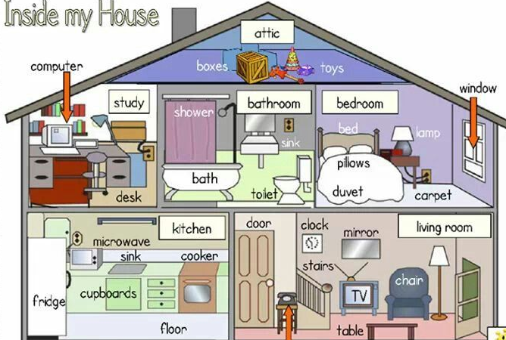
ROOF

UPSTAIRS

DOWNSTAIRS

(Vir: pinterest)

Oglejte si hišo na sliki in dopišite naslednje ter prevedite:
- Rooms in the house: _____________________________________________________

- Kaj pomeni: upstairs - _________________ / downstairs - ______________

a study - _____________ / chimney - ________________ / attic - __________________

- Things in the kitchen: ____________________________________________________

- Things in the living room - __________________________________________________

- Things in the bathroom - ____________________________________________________

- Things in the bedroom - ____________________________________________________

- Dodatno: kaj pomeni?

- a dining room - _________________ a roof - ______________

- a hall - __________________ a balcony - _________________

- a garage - ________________ a garden - ____________

3. THE LAZY BURGLAR (leni vlomilec)
A: V učbeniku na str.16 poslušajte posnetek, nato pa večkrat na glas preberite besedilo.
B: New words; kaj pomenijo naslednje besede?
a mess - ______________ a footprint - _____________
a drawer - _____________ a doormat - ______________
to find - _____________ a plate - _____________
suddenly - _______________ a saucepan - _____________
a vase - _____________ to laugh - _______________

C: Exercise – označite, ali je trditev pravilna ali napačna. Če je napačna, jo poravite
pravilno. TRUE – pravilno / FALSE - napačno
a. Madame Michel goes to a magic show. ______
b. When she comes home, the door is open. ______
c. She goes to the bedroom to look in the drawers. ______
d. There is no money in the drawer. ______
e. Then she calls her friends. ______
f. The burglar has got her money. ______
g. Madame Michel finds the burglar’s glasses and footprints. ______
h. The burglar likes vanilla cake. _______
i. In the end she finds the burglar asleep on her chair. _______
D: Rešite vaje v delovnem zvezku str. 14 in 15.
BYE BYE!

