5. G TJA UČENJE NA DALJAVO – 11. TEDEN (25.1. - 29.1. 2021)

1. My family
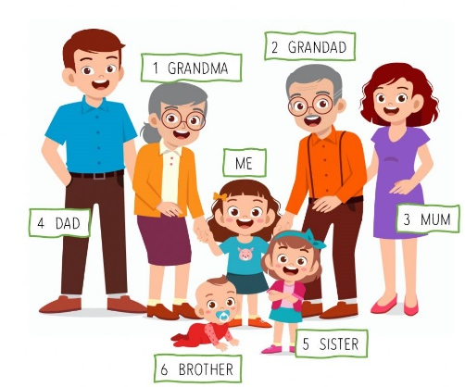
Hi. My name’s Mandy and this is my family.
My dad is David and he’s 40 years old. My
mum is Alice and she’s 38 years old. She’s a
teacher. I’ve got a sister and a baby brother.
My sister Lucy is 3 years old and brother
Sam is 5 months. I’ve got my grandpa and
grandma. They’re quite old but they like
playing with me. We are a happy family.
What about your family?
Podobno opišite svojo družino.

2. V učbeniku str. 24 /1 imate sliki A in B. Opišite ju primerjalno:

PICTURE A | PICTURE B
Sophie is drinking. | Sophie is eating.
Sam is…. | Sam is……

3. Sam’s photos (učb.24/2)
Najprej preberite 3 odstavke v rumenem. Nato pa odgovorite na vprašanja, napišite
za vsakega posebej, kaj dela na sliki:
Example:
a. Who are in the bedroom? My cousins Jack and Iona.
What are they doing? Iona is ……………….
Jack is ………………
b. Who are in the kitchen? _______________________________
What are they doing? _______________________________________________
c. Who are in the living room? ____________________________
What are they doing? ________________________________________________
d. Who are in the bathroom? _____________________________
What are they doing?

4. V učb. str. 31 rešite vaji.

DODATNO
- Poiščite kakšno primerno sliko svoje družine in opišite, kaj delate na sliki.

- Lahko se preizkusiš v igrici v različnih temah:
https://www.gamestolearnenglish.com/fast-english/

Lep pozdrav, učit. Vida L.

