5. G TJA UČENJE NA DALJAVO – 12. TEDEN (1. 2. - 5. 2. 2021)

1. Let’s repeat.
What are they doing? – uporabite naslednje: play tennis, buy shoes, talk on the
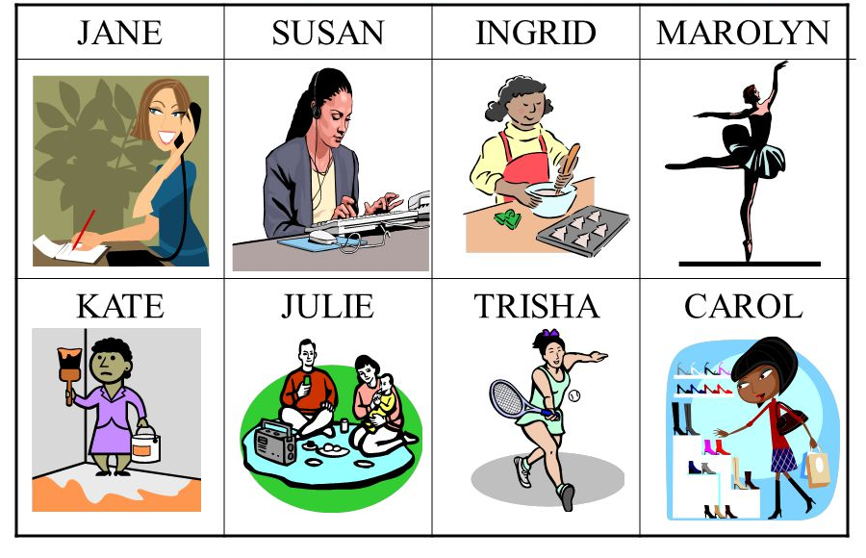
phone, dance, cook, paint, have picnic, write an e-mail

Jane is talking on the phone.

Vir: slideplayer
2. A FAMOUS ARTIST

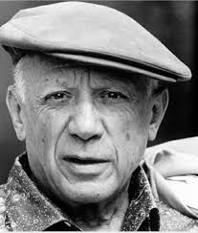
PABLO PICASSO – was born in Spain in 1881. He is the most
important artist of the 20th century. He was a painter, sculptor,
printmaker, theatre designer,…
His paintings, drawings, sculptures, ceramics and theatre
costumes are well-known(znan) all over the world.
He died in 1973. His most famous paintings:
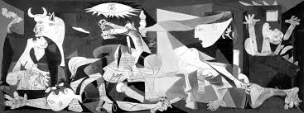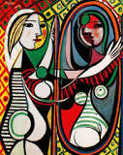
Guernica Girl Before a Mirror

A: Kaj pomeni?
a painter – a painting - __________________________
a sculptor – a sculpture - _________________________
a printmaker – a print - ___________________________

B: V učbeniku na strani 25 si preberite o slikah svetovno znanega umetnika in rešite
vajo 2.
Nove besede: lunchtime - ________________________
to give - _________________
a musician - _____________________
a clarinet - _______________________
Musical instruments: __________________________________________________________
(dodajte še nekaj izrazov za glasbene instrumente)

C: Kot smo se že dogovorili na Zoomu, izdelajte naslednjo nalogo za v mapico z naslovom
MY DRAWING
Na bel list A4 najprej narišite risbo, pobarvajte in jo nato opišite. Narišite več ljudi, živali, kjer
boste lahko uporabili glagole, ki izražajo različna opravila.
Primer: In this picture the boy is riding a bike.
3. A FAMOUS SLOVENE POET
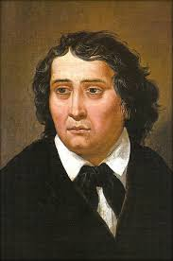
France Prešeren is the greates Slovenian poet.
He was born in Vrba in February 1800. He died in 1849 in Kranj.
His well-known poems are Zdravljica (A Toast), Urška and the
Waterman (Povodni mož), O Vrba,….

A: V učbeniku na strani 82 imate risbo Urške in povodnega moža. Opišite ju.
Lahko narišete tudi svojo risbo Urške in povodnega moža.

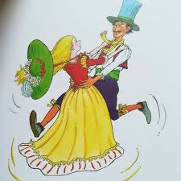 Lep pozdrav, učit. Vida L.

