6. G TJA UČENJE NA DALJAVO – 12. TEDEN (25.1. - 29.1. 2021)

1. Let’s repeat.
A: What’s the time?
a. 2.30 - __________________________ b. 4.50 - _______________________
b. 1.20 - __________________________ c. 3.30 - ________________________
d. 12.45 - _________________________ e. 6.15 - ________________________

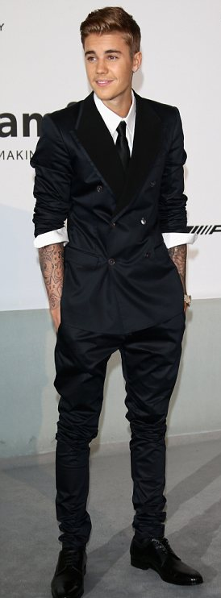
B: Describe a singer in the picture: (dodajte še druge podatke o osebi, ki jih poiščete na spletu).

This is Justin Bieber. He’s a singer. He ………………….

C: Kako hitri ste? Utrjujmo še oblačila v tej igrici:
https://www.gamestolearnenglish.com/fast-english/
D: Answer the questions:
a. What’s your favourite film character?
b. What’s your favourite possession?
c. What’s your favourite food?

E: Write short answers: Kratko odgovorite.
a. Do you read magazines? - Yes. / No.
b. When do you watch TV? - _________________
c. Do you play a musical instrument? - ____________
d. What do you usually wear on your feet? - ______________
e. How often do you use a computer? - ____________________
f. Do you eat a lot of crisps? - ______________
g. Do you drink tea or coffee? - _______________
h. Are you a good or a bad swimmer? - ___________________
i. What sport do you play? - ______________
j. How often do you go for a walk? - ______________

2. I GO TO A JUDO CLUB (učb. str. 58 /2a)
A: Na spodnji povezavi poslušajte posnetek(1.43) in nato večkrat preberite besedilo na glas.
B: Kaj pomeni?
I prefer - ______________________
I’m a computer addict. ________________________
nearly - ___________________

C: Besedilo nato prepišite v zvezek tako, kot da se predstavlja Sadie:
Hi, I’m Sadie. I live in the house. I like music and I’m in a band……..

D: Nato se podobno predstavite še sami.

DODATNO
Tu se lahko preizkusiš v izrazih za čas:
https://quizlet.com/9425429/flashcards/embed

Lep pozdrav, učit. Vida L.

