9. G TJA UČENJE NA DALJAVO – 12. TEDEN (25.1. - 29.1. 2021)

1. Let’s repeat.
A: Tenses: form the sentences in different tenses:
We / stay / at home Lucy / swim / in the pool
Present Simple ________________________
Present Continuous _________________________
Past Simple ___________________________
Past Continuous ________________________
“Will” future ______________________________
“Going to” future __________________________
Present Perfect ____________________________
Preverjanje o časih vam pošljem v sporočilih.

B: Modal verbs: change the sentence into the past and future:
a. You can do this better.
b. We don’t have to leave so early.
c. Can he be so rude?
d. I must write this e-mail now.
Preverjanjej o modalnih glagolih vam pošljem v sporočilih.

C: SHOULD – for giving advice
Example: a: Oh, no. I can’t send this e-mail. What SHOULD I do?
b: Well, maybe you SHOULD check your Internet connection.
a: Ok, thanks.
2. Travelling
A: Rešite interaktivne vaje na tej povezavi:
https://www.liveworksheets.com/worksheets/en/English_as_a_Second_Language_(ESL)/Travelling_vocabulary/Travelling_around_fk782307no
B: Fill in the missing words (pomagaj si z učnim listom prejšnjega tedna).
a. When the bus arrived we had to ___________________ very quickly.
b. While travelling by train ___________________ entered ___________ to check our tickets.
c. I checked all _________________ before I went to the lounge.
d. The place where passenger go to board the plane is called ___________________
e. ____________________ served some water just after the plane took off.
f. The place where you can put your hand luggage is called __________________.
g. I got a terrible _________________ on the turbulent sea.
h. We admired that big __________________ which was ready to cross the Atlantic ocean.
C: Answer the questions:
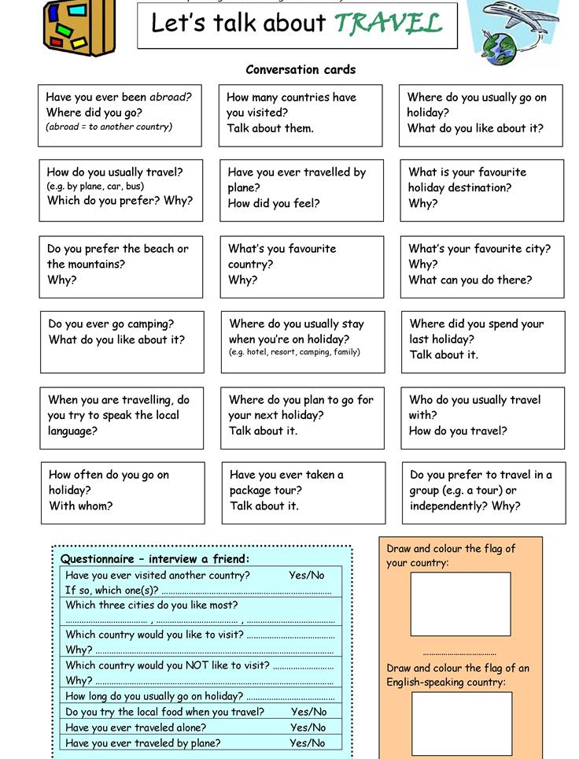
Vir: islcollective

Lep pozdrav, učit. Vida L.

